|  |  |
| --- | --- |
| Use Case UC-7： | Confirm user information |
| Related Requirements: | REQ3，REQ6, REQ7 stated in Table 2-1 |
| Initiating Actor: | Any of: student, teacher, society |
| Actor’s Goal: | The administrator enters the background to confirm whether the information entered by the user is incorrect. |
| Participating Actors: | Asa |
| Preconditions: | • The administrator logs in the correct username and password.  • The administrator verifies that the user's valid information is incorrect. |
| Post-conditions: | User-published information is subject to legal permission. |
| Flow of Events for Main Success Scenario: | |
| → | 1.The administrator enters the background service interface through the account number and password. |
| → | 2.The administrators can view all user information on the background service interface. |
| ← | 3.After the administrator reviews the information, the platform will feed back the results to the user. |

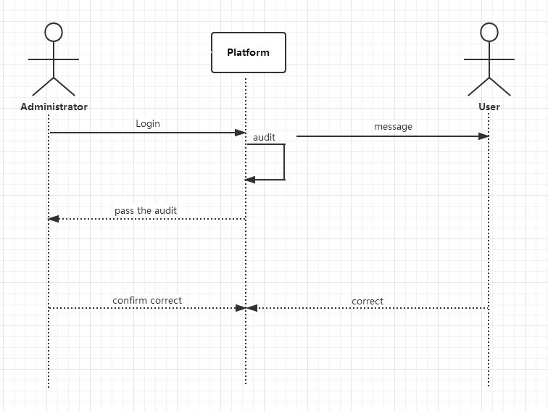

|  |  |
| --- | --- |
| Use Case UC-8： | Orders |
| Related Requirements: | REQ6，REQ7, REQ8 stated in Table 2-1 |
| Initiating Actor: | Any platform service staff |
| Actor’s Goal: | The service provider arrives at the required location on time to service the user and complete the payment on the platform. |
| Participating Actors: | Asa |
| Preconditions: | • Users complete payment.  • Users and service providers do their own preparations in the same time. |
| Post-conditions: | Users and service providers should cooperate with each other within the scope permitted by law. |
| Flow of Events for Main Success Scenario: | |
| → | 1.The platform will automatically post user service information to the server. |
| → | 2.The service provider arrives at the user's request location in time for service. |
| ← | 3.After the service is completed, the user can evaluate the server on the platform. |

